|  |  |
| --- | --- |
| Position Title | Feedmill Supervisor |
| Position Location | Teys Australia Feedlots |
| Department | Feedlot |
| Employment Type | Full Time |
| Peer Roles | Other Feedlot Supervisors |

**BACKGROUND**

**“FEEDING PEOPLE, ENRICHING LIVES”**

Teys Australia is an innovative Australian food business with home grown pride and global reach. We enrich lives every day and together thrive on a spirit of opportunity.

Over 4,700 people work across the eastern seaboard of Australia at 11 locations where we focus our energy and expertise on optimising the journey from paddock to plate to deliver value to our communities, customers and consumers.

We are the second largest beef processor and exporter in Australia, and proud partners to over 7,000 Aussie beef producers and some of the largest names in fresh food retailing in the country.

In a joint venture with Cargill, Teys Australia has retained its strong founding family connections and it is this rich heritage that drives our future.

**REPORTING LINES**

**POSITION OBJECTIVES**

Lead and manage the feed mill department and generally provide assistance and assist the General Manager in the effective and profitable operation of the feedlot

**KEY ACCOUNTABILITIES**

***MILL***

* Ensure that all milling and feeding activities are being conducted in accordance with requirements
* Ensure that feed commodities are processed and delivered within the business specifications
* Monitor the daily feed allocation for the purpose of general animal consumption and health across the feedlot
* Liaise with and assist the maintenance department with coordination of priorities when a breakdown occurs or preventative maintenance is required that interrupts the daily feeding or milling operations
* Engage with feedlot animal nutritional consultants when required

***MAINTENANCE***

* Assist maintenance manager in managing R & M costs and time frames of completion
* Help prioritise and facilitate maintenance tasks across the feedlot

***CONTRACTORS***

* Manage all approved contractors on site and assist feedlot management in the engagement of contractors when required

***WORK HEALTH AND SAFETY***

* Take reasonable care for your own health and safety.
* Ensure compliance with the corporate and site Safety Management System at all times
* Promote, support and co-operate with all Teys Australia polices or procedures relating to health or safety at the workplace.
* Provide positive leadership in an effort to enhance and improve safety behaviours and the safety culture.
* Conduct regular STOP inspections
* Ensure employees adheres to Golden Rules Policy

### *Staff Related Matters*

* Ensure mannings are maintained at approved levels ,any alterations are with prior approval and direct labour costs are maintained within budget.
* Ensure overtime is minimised.
* Induct new employees on the job.
* Identify employee training needs and organise/conduct necessary training.
* Lead, direct, supervise, train and counsel employees.
* Ensure all necessary documentation is completed accurately and on time (e.g. payroll, HR, OH&S, product data)
* Create an atmosphere of teamwork and harmony amongst employees (engagement drivers).

**SELECTION CRITERIA**

*Essential:*

* Three (3+) years’ experience in a feedlot, livestock or pastoral management role
* Five (5+) years’ experience in general feedlot, livestock, or pastoral roles
* Knowledge of general Workplace Health & Safety standards
* Knowledge of contemporary animal husbandry techniques
* Current drivers licence
* Personal qualities of leadership, financial acumen and communication

*Desirable:*

* Possession of or satisfactory progress towards attainment of tertiary qualifications in a relevant agricultural science

**BENEFITS AND CONDITIONS**

The below outlines the range benefits and conditions enjoyed by Teys Australia salaried staff and some key conditions.

|  |  |
| --- | --- |
| **BENEFITS** | **CONDITIONS** |
| Annual Meat Allowance | National Employment Standards |
| Salary Sacrifice Options | Fair Work Information Statement |
| Injury/Illness Salary Continuance Scheme | Common Law Salary Staff Contract |
| Short Term Incentive Scheme |  |
| Company Supplied Mobile Phone |  |

**LEADERSHIP MODEL AND BEHAVIOURS**

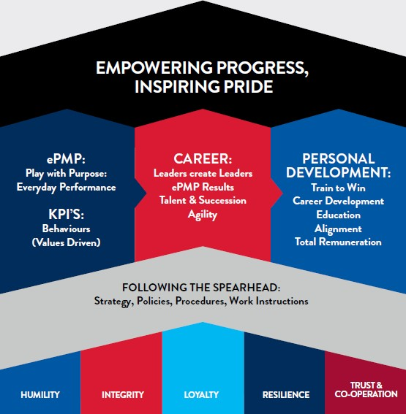

**KEY PERFORMANCE INDICATORS (KPI’S)**

|  |  |
| --- | --- |
| **INDICATOR** | **TARGET AND/OR WEIGHTING** |
| Safety | 30% |
| Operational Excellence | 30% |
| Employer of Choice | 20% |
| Profitable Growth | 20% |