Position Title | Administration Officer
Position Location | Teys Australia, Charlton Feedlot
Department | Office
Employment Type | Full Time

BACKGROUND
“FEEDING PEOPLE, ENRICHING LIVES”
Teys Australia is an innovative Australian food business with home grown pride and global reach. We enrich lives every day and together thrive on a spirit of opportunity.
Over 4,700 people work across the eastern seaboard of Australia at 11 locations where we focus our energy and expertise on optimising the journey from paddock to plate to deliver value to our communities, customers and consumers.
We are the second largest beef processor and exporter in Australia, and proud partners to over 7,000 Aussie beef producers and some of the largest names in fresh food retailing in the country.
In a joint venture with Cargill, Teys Australia has retained its strong founding family connections and it is this rich heritage that drives our future.

REPORTING LINES

POSITION OBJECTIVES:
Provide all daily administrative office functions at Charlton Feedlot

KEY ACCOUNTABILITIES
- Liaising with internal and external customers – telephone & visitors
- Act as contact point for producer inquiries, contractors and visitors
- Weighbridge operations – cattle in & out, commodity receivals and manure sales
- Adhering with all CoR requirements
- Grain testing – ensuring meeting required standards
- Undertake all required training as needed
- Use of Feedlot 3000 & Stockaid programs
- Ensure any office policies and procedures are being adhered to
- Provide backup for the other roles within the office as and when necessary
- All other office duties as required
- Ensure office security and confidentiality of data and records
- Provide regular and ad-hoc reports as requested by management
- General Ledger - Accounts receivable / payable, foreign currency payments as required, data entry, enquiry, reconciliation and reporting of information
- Supplies ordering and receival
- Maintenance of contact and address book information in feedlot and financial systems
- Streamline tasks to improve efficiency
- Perform other duties based on your skills and experience or as directed by the General Manager Charlton Feedlot

SELECTION CRITERIA
Essential:
- Diploma in Business/Office Administration or related qualification
- A rural background and knowledge of the cattle industry
- Minimum of 5 years experience in an office environment
- Computer literacy – Excel, Word, Access & JD Edwards & Other Software Packages
Desirable:
- Current drivers licence

BENEFITS AND CONDITIONS
The below outlines the range benefits and conditions enjoyed by Teys Australia salaried staff and some key conditions.
BENEFITS | CONDITIONS
Annual Meat Allowance | National Employment Standards
Short Term Incentive (if applicable) | Fair Work Information Statement
Salary Sacrifice Options | Common Law Salary Staff Contract
Injury/Illness Salary Continuance Scheme | Business Conduct Principles

LEADERSHIP MODEL AND BEHAVIOURS
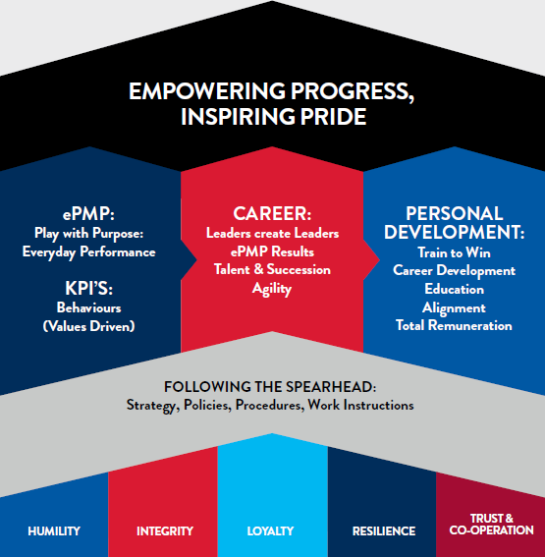

HAYGROUP JOB BANDING AND EVALUATION
Know How
Problem Solving
Accountability
Profile
Hay Group Points
Hay Group Level
Job Banding
Rated By
Checked By

